EXPERIMENT NO.1

- VHDL CODE:

-- Experiment No 1. To Study Design Flow using an EDA Tool
-- Name : Ritesh Machindra Todmal
-- Roll No. : 404C001
-- Teacher Name: Dr.D.G.Ganage
-- Batch : C1

library IEEE;
use IEEE.STD_LOGIC_1164.ALL;
entity FA is
Port ( A : in STD_LOGIC;
B : in STD_LOGIC;
Cin : in STD_LOGIC;
Sum : out STD_LOGIC;
Cout : out STD_LOGIC);
end FA;
architecture Behavioral of FA is
begin
Sum <= (A xor B xor Cin);
Cout <= ((A and B) or (B and Cin) or (A and Cin));
end Behavioral;

- VHDL TESTBENCH:

-- Experiment No 1- To Study Design Flow using an EDA Tool
-- Name : Ritesh Machindra Todmal
-- Roll No. : 404C001
-- Teacher Name: Dr.D.G.Ganage
-- Batch : C1

LIBRARY ieee;
USE ieee.std_logic_1164.ALL;

ENTITY FA_Test IS
END FA_Test;

ARCHITECTURE behavior OF FA_Test IS

COMPONENT FA
PORT(
A : IN std_logic;
B : IN std_logic;
Cin : IN std_logic;
Sum : OUT std_logic;
Cout : OUT std_logic
);
END COMPONENT;

--Inputs
signal A : std_logic := '0';
signal B : std_logic := '0';
signal Cin : std_logic := '0';

--Outputs
signal Sum : std_logic;
signal Cout : std_logic;
-- No clocks detected in port list. Replace <clock> below with
-- appropriate port name

BEGIN

-- Instantiate the Unit Under Test (UUT)
uut: FA PORT MAP (
A => A,
B => B,
Cin => Cin,
Sum => Sum,
Cout => Cout
);

-- Stimulus process
stim_proc: process
begin
a <= '0';
b <= '0';
Cin <= '0';
wait for 20 ns;

a <= '0';
b <= '1';
Cin <= '0';
wait for 20 ns;

a <= '1';
b <= '0';
Cin <= '1';
wait for 20 ns;

a <= '1';
b <= '1';
Cin <= '1';
wait for 20 ns;

end process;

END;

- SIMULATION RESULT

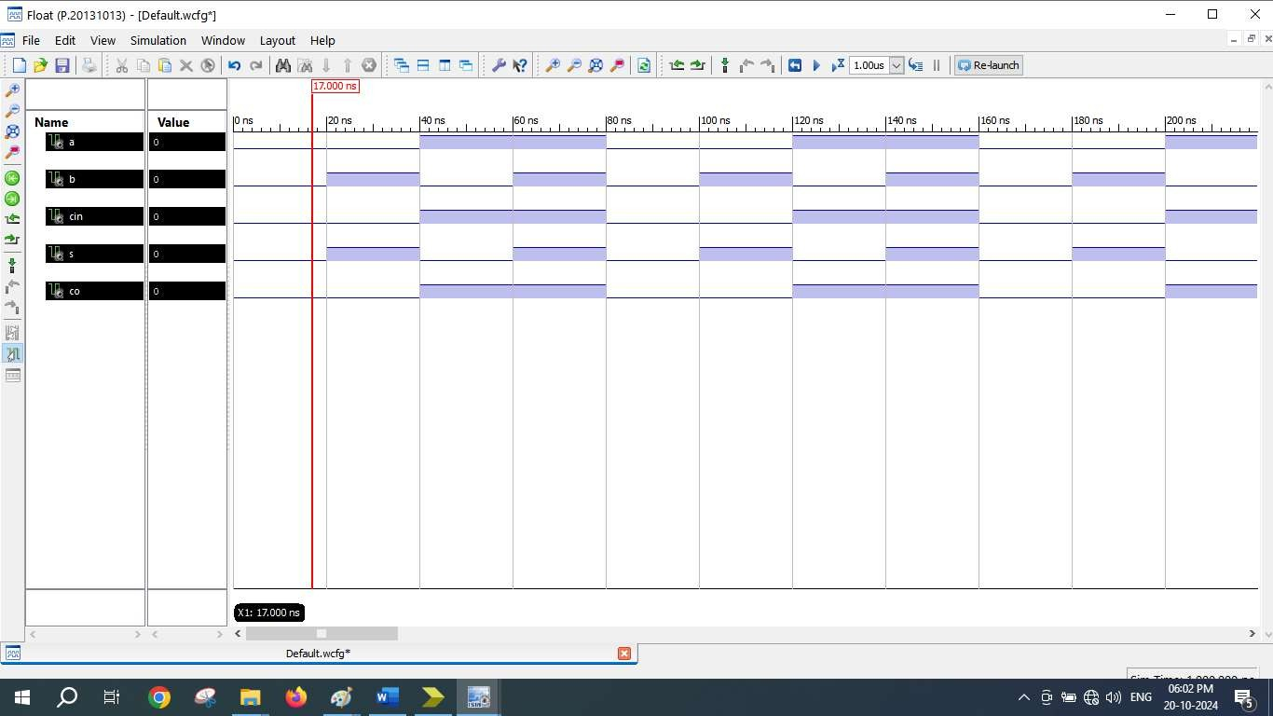

- SCHEMATICS (RTL Technology)

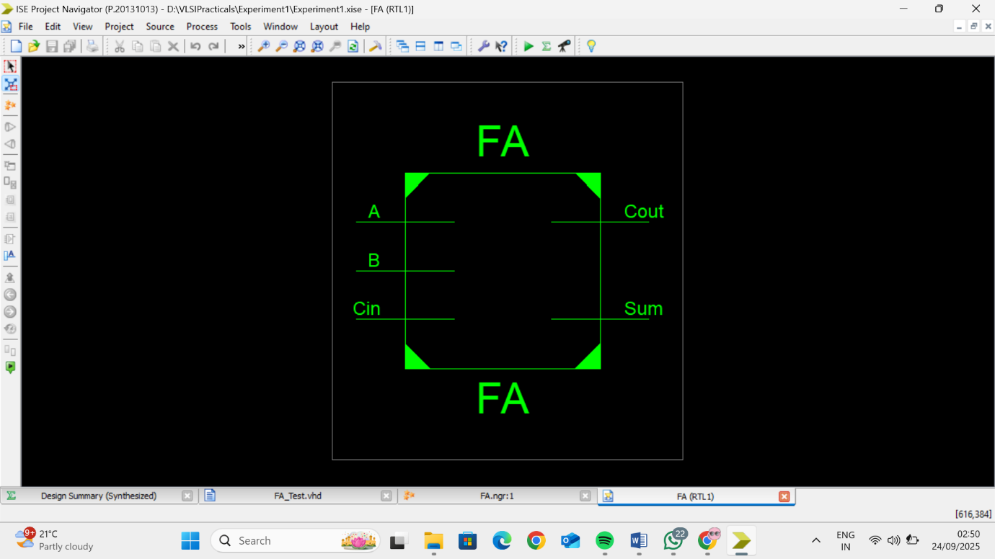

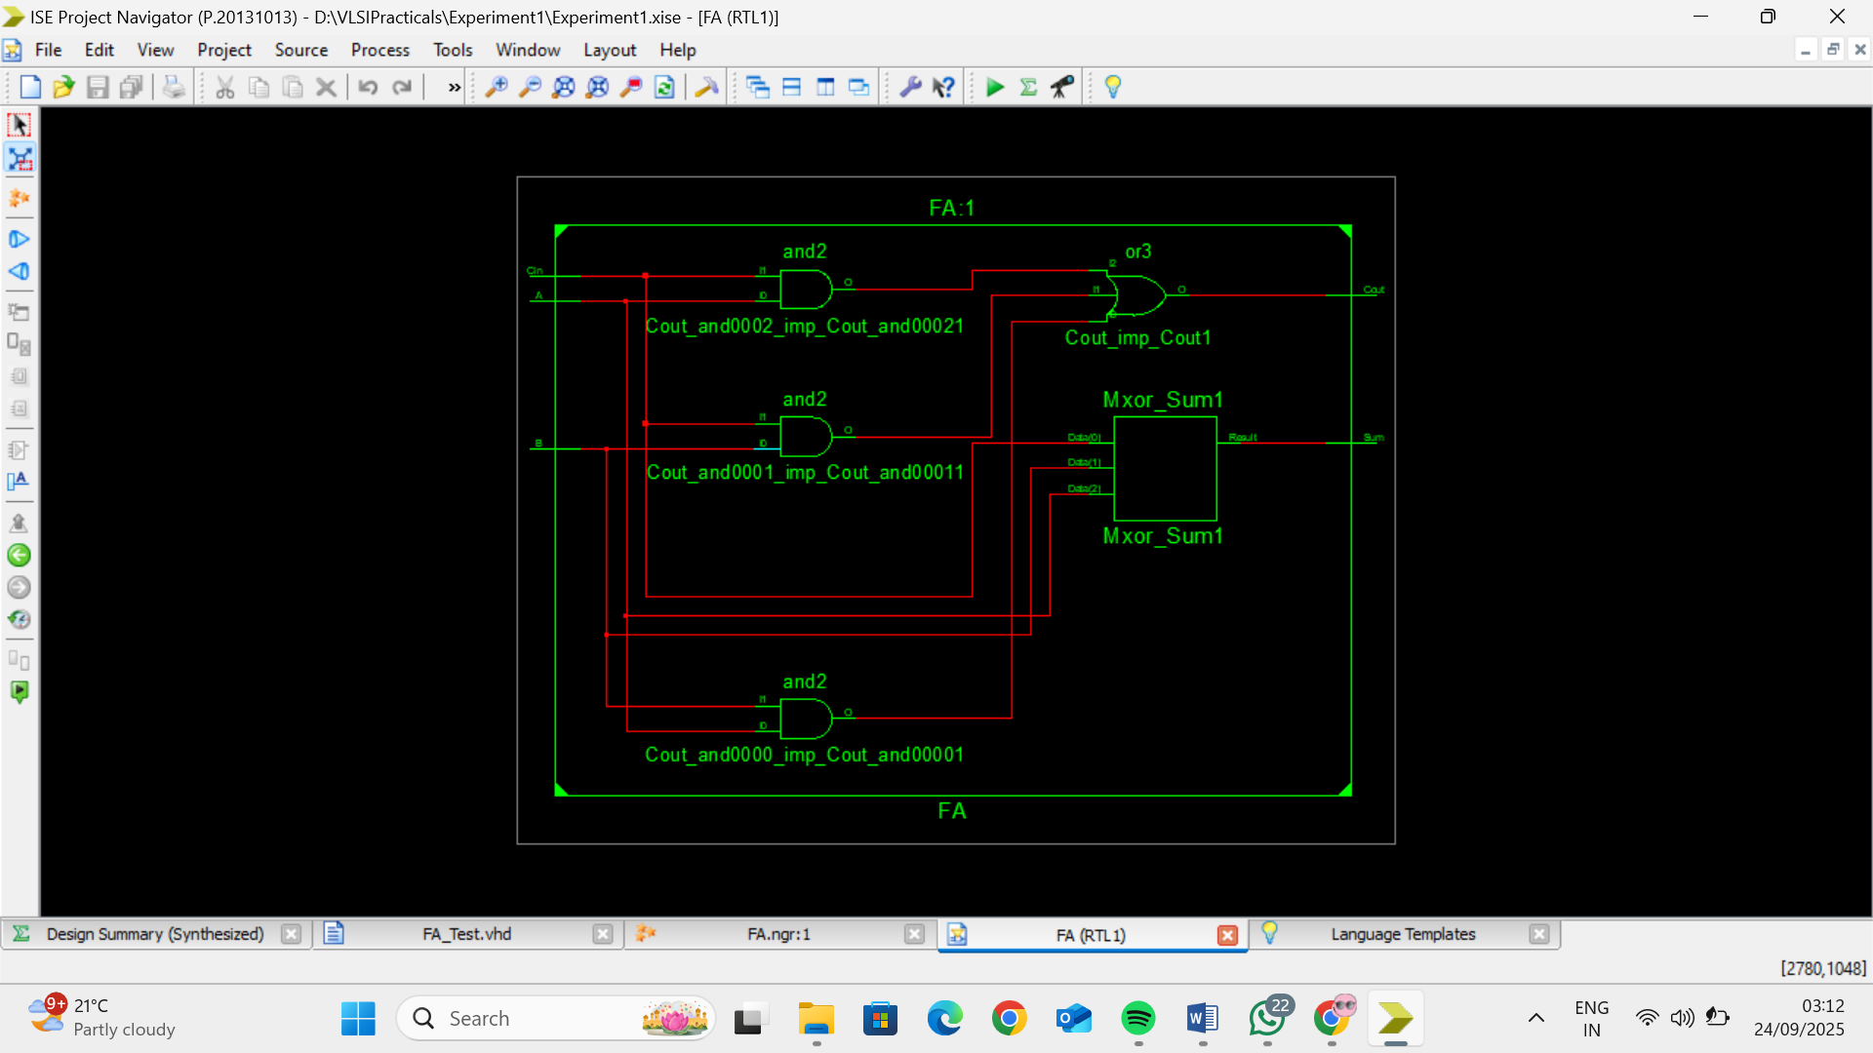
=========================================================================
* Final Report *
=========================================================================
Final Results
RTL Top Level Output File Name : fa.ngr Top Level Output File Name : fa
Output Format : NGC
Optimization Goal : Speed
Keep Hierarchy : No

Design Statistics
# IOs : 5

Cell Usage :
# BELS : 2
# LUT3 : 2
# IO Buffers : 5
# IBUF : 3
# OBUF : 2
=========================================================================

Device utilization summary:

Selected Device : 3s250epq208-5

Number | of | Slices: | 1 | out | of | 2448 | 0%
Number | of | 4 input LUTs: | 2 | out | of | 4896 | 0%
Number | of | IOs: | 5
Number | of | bonded IOBs: | 5 | out | of | 158 | 3%

